Dropwizard Workshop Instructions

This document contains the instructions to develop the workshop exercises.

Note: You may copy and paste the codes in this document to your created classes. Alternatively, you can clone the project from [github](https://github.com/wandatinkers/dw-demos) if you want the complete version.

Part 1: Dropwizard Basic Components [dwdemopart1]

This exercise will go through the bare minimum needed to create and run your own dropwizard application.

1.1 Create new Maven project

Open IDE and then click Create New Project. Choose the maven-archetype-quickstart, then enter ***Group Id*** and ***Artifact Id***, and finally press ***Finish***.

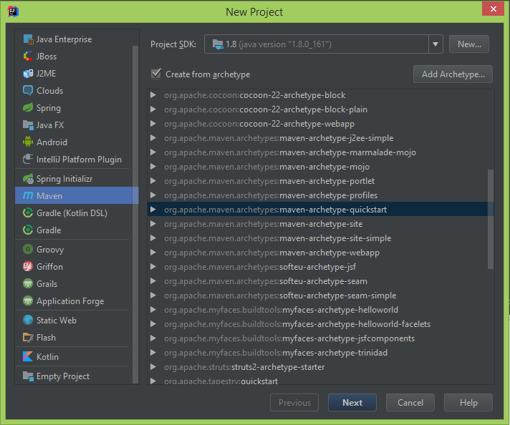

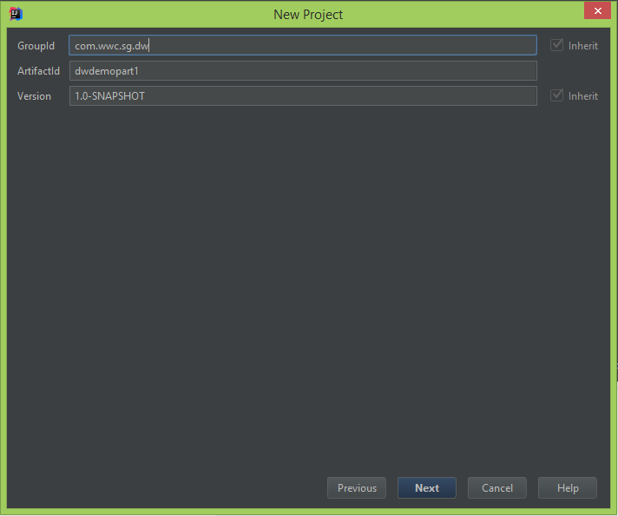

## 

## 1.2 Update the pom.xml

Now update the pom.xml file to include the dropwizard-core maven dependency. We will also update the Maven project to use Java version 1.8. After updating the pom.xml file, update the Maven Project(Right Click on pom.xml > Maven > Reimport)

<?xml version="1.0" encoding="UTF-8"?>  
<project xmlns="http://maven.apache.org/POM/4.0.0"  
 xmlns:xsi="http://www.w3.org/2001/XMLSchema-instance"  
 xsi:schemaLocation="http://maven.apache.org/POM/4.0.0 http://maven.apache.org/xsd/maven-4.0.0.xsd">  
 <modelVersion>4.0.0</modelVersion>  
  
 <groupId>com.wwc.sg.dw</groupId>  
 <artifactId>dw-demo-part1</artifactId>  
 <name>Dropwizard Demo - Basic components</name>  
 <version>1.0-SNAPSHOT</version>

<properties>  
 <dropwizard.version>1.2.2</dropwizard.version>  
 </properties>  
  
 <dependencies>  
 <dependency>  
 <groupId>io.dropwizard</groupId>  
 <artifactId>dropwizard-core</artifactId>  
 <version>${dropwizard.version}</version>  
 </dependency>  
 </dependencies>  
  
 <build>  
 <plugins>  
 <plugin>  
 <groupId>org.apache.maven.plugins</groupId>  
 <artifactId>maven-compiler-plugin</artifactId>  
 <configuration>  
 <source>1.8</source>  
 <target>1.8</target>  
 </configuration>  
 </plugin>  
 </plugins>  
 </build>  
</project>

## 1.3 Create a Configuration YAML file

This configuration file will contain the environment specific properties of your application. There are other pre-defined properties available in Dropwizard, we will mention them as we go along this workshop.

**application:** Dropwizard Demo Application  
**environment:** DEV  
**version:** 1.0  
**template:** Hello, %s!

## 1.4 Create Configuration class

A dropwizard application has one configuration class which specifies the environment specific parameters. This maps to the config yml file.   
This class extends the **io.dropwizard.Configuration** class.

package com.wwc.sg.dw;  
  
import io.dropwizard.Configuration;  
  
public class DWDemoAppConfiguration extends Configuration {  
  
 private String application;  
 private String environment;  
 private String version;  
 private String template;  
  
 public String getApplication() {  
 return application;  
 }  
  
 public void setApplication(String application) {  
 this.application = application;  
 }  
  
 public String getEnvironment() {  
 return environment;  
 }  
  
 public void setEnvironment(String environment) {  
 this.environment = environment;  
 }  
  
 public String getVersion() {  
 return version;  
 }  
  
 public void setVersion(String version) {  
 this.version = version;  
 }  
  
 public String getTemplate() {  
 return template;  
 }  
  
 public void setTemplate(String template) {  
 this.template = template;  
 }  
  
}

## 1.5 Create Resource class

Resources are the meat of a Dropwizard application. Resources exposes our rest endpoints.

package com.wwc.sg.dw.resources;  
  
import javax.ws.rs.GET;  
import javax.ws.rs.Path;  
import javax.ws.rs.PathParam;  
import javax.ws.rs.Produces;  
import javax.ws.rs.core.MediaType;  
import javax.ws.rs.core.Response;  
  
@Path("/")  
@Produces(MediaType.APPLICATION_JSON)  
public class IndexResource {  
  
 private String name;  
 private String environment;  
 private String version;  
 private String template;  
  
 public IndexResource(String name, String environment, String version, String template){  
 this.name = name;  
 this.environment = environment;  
 this.version = version;  
 this.template = template;  
 }  
  
 @GET  
 public Response getVersion() {  
 StringBuffer sb = new StringBuffer();  
 sb.append("Application:" + name + "\n");  
 sb.append("Environment:" + environment + "\n");  
 sb.append("Version:" + version + "\n");  
 return Response.ok(sb.toString()).build();  
 }  
  
 @GET  
 @Path("hello/{name}")  
 public Response printGreeting(@PathParam("name") String name) {  
 final String greeting = String.format(template, name);  
 return Response.ok(greeting).build();  
 }  
}

## 1.6 Create Application class

This is the main entry point for any Dropwizard application. This class extends the ***io.dropwizard.Application*** class and have access to the Configuration and Environment objects. They prepare the runtime environment of the application.

package com.wwc.sg.dw;  
  
import com.wwc.sg.dw.resources.IndexResource;  
import io.dropwizard.Application;  
import io.dropwizard.configuration.ResourceConfigurationSourceProvider;  
import io.dropwizard.setup.Bootstrap;  
import io.dropwizard.setup.Environment;  
  
public class DWDemoApp extends Application<DWDemoAppConfiguration> {  
  
 public static void main(String[] args) throws Exception {  
 new DWDemoApp().run(new String[] { "server", "DWDemoApp.yml"});  
 }  
  
 @Override  
 public void initialize(Bootstrap<DWDemoAppConfiguration> bootstrap) {  
 bootstrap.setConfigurationSourceProvider(  
 new ResourceConfigurationSourceProvider());  
 }  
  
 @Override  
 public void run(DWDemoAppConfiguration configuration, Environment environment) throws Exception {  
 final IndexResource resource = new IndexResource(  
 configuration.getApplication(),  
 configuration.getEnvironment(),  
 configuration.getVersion(),  
 configuration.getTemplate()  
 );  
 environment.jersey().register(resource);  
 }  
}

**1.7** Build your application

It is recommended to build and package your application as a single deployable artefact.

To do this, we need to use the maven shade plugin.

Add to pom.xml the maven shade plugin.

<build>  
 <plugins>  
 <plugin>  
 <groupId>org.apache.maven.plugins</groupId>  
 <artifactId>maven-compiler-plugin</artifactId>  
 <version>3.7.0</version>  
 <configuration>  
 <source>1.8</source>  
 <target>1.8</target>  
 </configuration>  
 </plugin>  
 <!-- build fat jar -->  
 <plugin>  
 <groupId>org.apache.maven.plugins</groupId>  
 <artifactId>maven-shade-plugin</artifactId>  
 <version>3.1.0</version>  
 <executions>  
 <execution>  
 <phase>package</phase>  
 <goals>  
 <goal>shade</goal>  
 </goals>  
 <configuration>  
 <transformers>  
 <transformer implementation="org.apache.maven.plugins.shade.resource.ManifestResourceTransformer">  
 <mainClass>com.wwc.sg.dw.DWDemoApp</mainClass>  
 </transformer>  
 </transformers>  
 </configuration>  
 </execution>  
 </executions>  
 </plugin>  
 </plugins>  
  
</build>

Build and package the maven project. On the Maven Projects window, right-click on ***Package***, then click ***Run Maven Build***. This will create the executable jar file in <project_dir>/target folder.

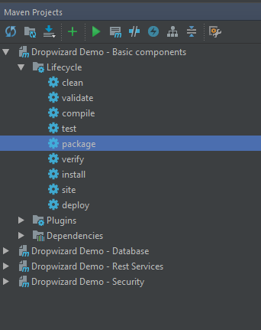

**1.8** Run your application

In Intellij, go to View -> Tool Windows -> Terminal.

Go to dwdemopart1/target, execute: ***java -jar dw-demo-part1-1.0-SNAPSHOT.jar***

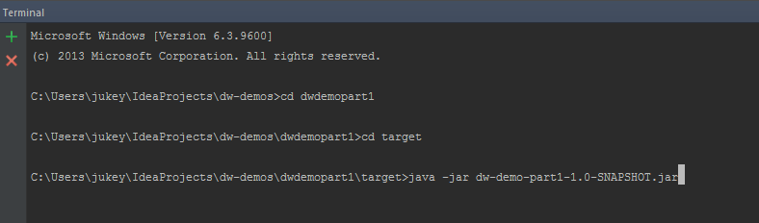

In the application startup log, the exposed endpoints will be listed.

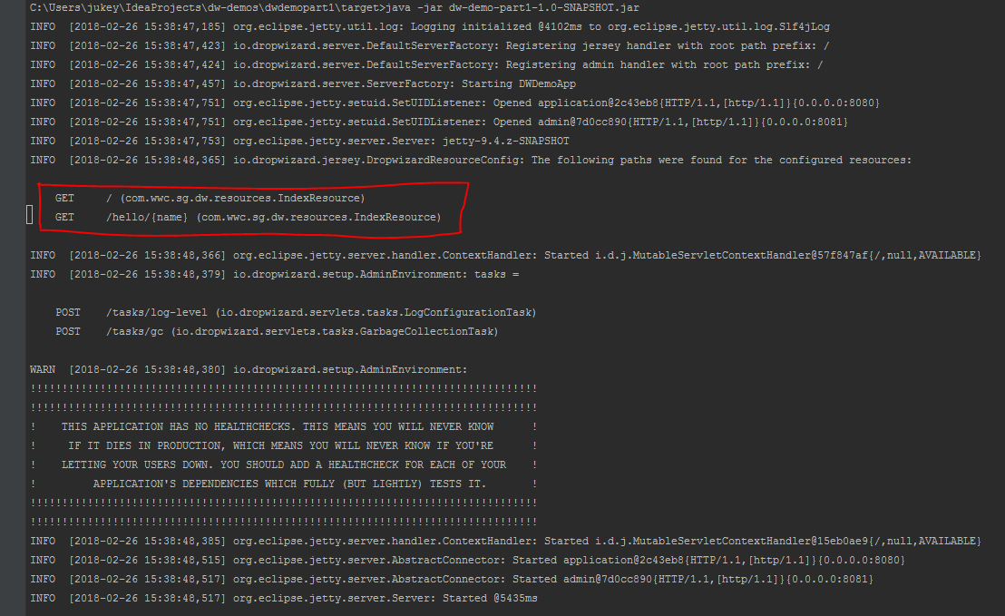

**1.9** Access rest endpoints

In chrome, access the following URI:

1. <http://localhost:8080/>

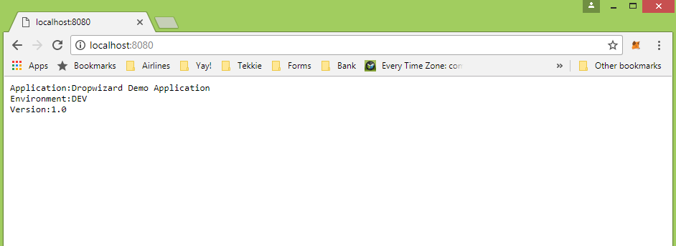

1. [http://localhost:8080/hello/<your_name](http://localhost:8080/hello/%3cyour_name)> e.g. <http://localhost:8080/hello/Ianne>

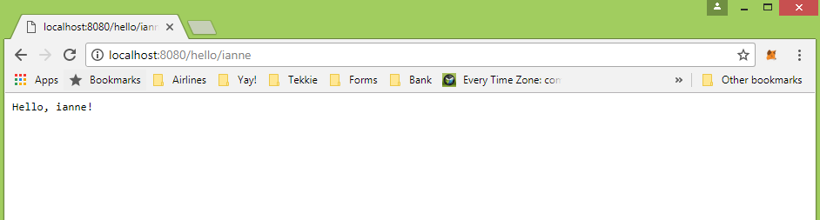

Part 2: Dropwizard Rest Services [dwdemopart2]

In this exercise, we will extend the codes in Part 1 and develop a very simple rest service that will display a list of book titles and its author.

2.1 Create a representation class

Representations are real-world objects modelled as POJOs. For this exercise, our model object is that of a Book object.

package com.wwc.sg.dw.representations;  
  
import java.util.concurrent.atomic.AtomicInteger;  
  
public class Book {  
  
 private static AtomicInteger *ctr* = new AtomicInteger(0);  
  
 private int id;  
 private String title;  
 private String author;  
  
 public Book(String title, String author) {  
 this.id = *ctr*.incrementAndGet();  
 this.title = title;  
 this.author = author;  
 }  
  
 public int getId() {  
 return id;  
 }  
  
 public void setId(int id) {  
 this.id = id;  
 }  
  
 public String getTitle() {  
 return title;  
 }  
  
 public void setTitle(String title) {  
 this.title = title;  
 }  
  
 public String getAuthor() {  
 return author;  
 }  
  
 public void setAuthor(String author) {  
 this.author = author;  
 }  
}

2.2 Create a new resource

Resources provide access to manipulate our objects.

package com.wwc.sg.dw.resources;  
  
import com.wwc.sg.dw.representations.Book;  
  
import javax.ws.rs.GET;  
import javax.ws.rs.Path;  
import javax.ws.rs.PathParam;  
import javax.ws.rs.Produces;  
import javax.ws.rs.core.MediaType;  
import javax.ws.rs.core.Response;  
import java.util.ArrayList;  
import java.util.List;  
  
@Path("/catalog")  
@Produces(MediaType.*APPLICATION_JSON*)  
public class BookCatalogResource {  
  
 private static List<Book> *books* = new ArrayList<>();  
 static{  
 *books*.add(new Book("'Autumn'", "Ali Smith"));  
 *books*.add(new Book("Exit West", "Mohsin Hamid"));  
 *books*.add(new Book("Pachinko", "Min Jin Lee"));  
 }  
  
 public BookCatalogResource() {  
 }  
  
 @GET  
 @Path("/book")  
 public Response getBooks() {  
 return Response.*ok*(*books*).build();  
 }  
  
 @GET  
 @Path("/book/{id}")  
 public Response getBooksById(@PathParam("id") int id) {  
 try {  
 Book book = *books*.get(id-1);  
 return Response.*ok*(book).build();  
 } catch (Exception e){  
 return Response.*ok*("No book found.").build();  
 }  
 }  
}

2.3 Register new resource

@Override  
public void run(DWDemoAppConfiguration configuration, Environment environment) throws Exception {  
 final IndexResource indexResource = new IndexResource(  
 configuration.getApplication(),  
 configuration.getEnvironment(),  
 configuration.getVersion(),  
 configuration.getTemplate()  
 );  
 environment.jersey().register(indexResource);  
 environment.jersey().register(new BookCatalogResource());  
}

2.4 Build and deploy in a new custom port of the embedded server

1. Add the configuration for the custom part in the config yml file.

**application:** Dropwizard Demo Application  
**environment:** DEV  
**version:** 2.0  
**template:** Hello, %s!  
  
**server:  
 applicationConnectors:** - **type:** http  
 **port:** 8090  
 **adminConnectors:** - **type:** http  
 **port:** 8091

1. Build and run application (Refer to steps 1.6 and 1.7 in Part 1).

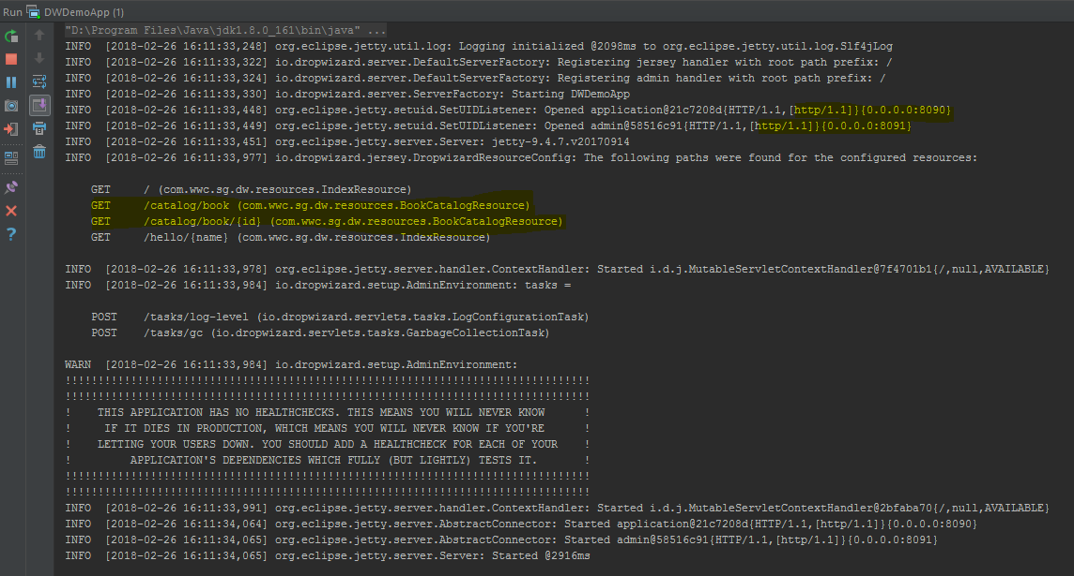

2.5 Access new rest endpoints

In chrome, access the following URI:

1. <http://localhost:8090/catalog/book>

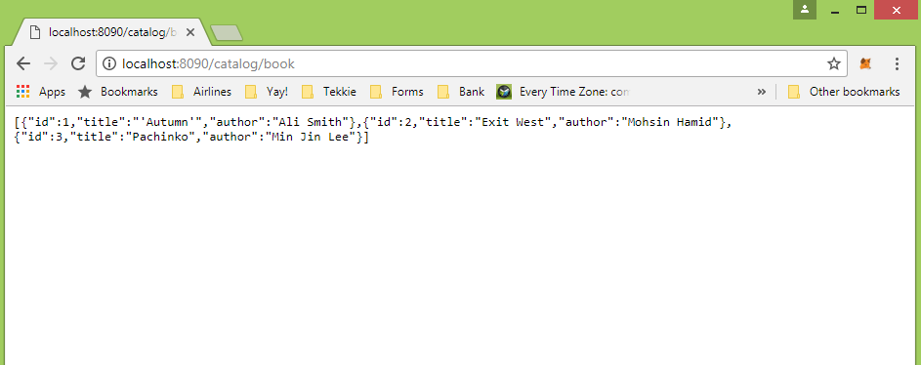

1. <http://localhost:8090/catalog/book/1>

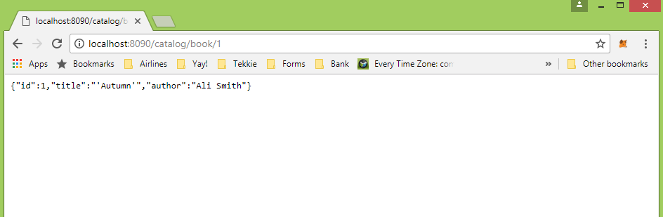

Part 3: Dropwizard - Database Access [dwdemopart3]

In this exercise, we will extend the codes in Part 2 to source the list of books from the database. We will be using the h2 in-mem db and dropwizard-hibernate add-on bundle for this.

3.1 Add hibernate bundle as dependencies in the pom.xml

<groupId>com.wwc.sg.dw</groupId>  
<artifactId>dw-demo-part3</artifactId>  
<name>Dropwizard Demo - Database</name>  
<version>1.0-SNAPSHOT</version>  
  
<properties>  
 <dropwizard.version>1.2.2</dropwizard.version>  
</properties>  
  
<dependencies>  
 <dependency>  
 <groupId>io.dropwizard</groupId>  
 <artifactId>dropwizard-core</artifactId>  
 <version>${dropwizard.version}</version>  
 </dependency>  
 <dependency>  
 <groupId>io.dropwizard</groupId>  
 <artifactId>dropwizard-hibernate</artifactId>  
 <version>${dropwizard.version}</version>  
 </dependency>  
 <dependency>  
 <groupId>com.h2database</groupId>  
 <artifactId>h2</artifactId>  
 <version>1.4.190</version>  
 </dependency>  
</dependencies>

3.2 Configure the database connection settings

*# Database settings.***database:** *# the name of your JDBC driver* **driverClass:** org.h2.Driver  
  
 *# the username* **user:** sa  
  
 *# the password* **password:** sa  
  
 *# the JDBC URL* **url:** jdbc:h2:./db/dwdemos  
  
 **properties:** *# javax.persistence.schema-generation.database.action: drop-and-create* **hibernate.dialect:** org.hibernate.dialect.H2Dialect  
 **hibernate.hbm2ddl.auto:** create  
 **hibernate.hbm2ddl.import_files:** init_data.sql  
 **hibernate.show_sql:** false

3.3 Create sql file for the dataset

**insert into** book(id, title, author) **values** (1, 'Autumn','Ali Smith');  
**insert into** book(id, title, author) **values** (2, 'Exit West','Mohsin Hamid');  
**insert into** book(id, title, author) **values** (3, 'Pachinko','Min Jin Lee');  
**insert into** book(id, title, author) **values** (4, 'The Power','Naomi Alderman');  
**insert into** book(id, title, author) **values** (5, 'Sing, Unburied, Sing','Jesmyn Ward');  
**insert into** book(id, title, author) **values** (6, 'The Evolution of Beauty: How Darwin’s Forgotten Theory of Mate Choice Shapes the Animal World — and Us','Richard O. Prum');  
**insert into** book(id, title, author) **values** (7, 'Grant','Ron Chernow');  
**insert into** book(id, title, author) **values** (8, 'Locking Up Our Own: Crime and Punishment in Black America','James Forman Jr.');  
**insert into** book(id, title, author) **values** (9, 'Prairie Fires: The American Dreams of Laura Ingalls Wilder','Caroline Fraser');  
**insert into** book(id, title, author) **values** (10, 'Priestdaddy','Patricia Lockwood');

3.4 Make the database factory accessible in the Configuration class

package com.wwc.sg.dw;  
  
import com.fasterxml.jackson.annotation.JsonProperty;  
import io.dropwizard.Configuration;  
import io.dropwizard.db.DataSourceFactory;  
import javax.validation.constraints.NotNull;  
  
public class DWDemoAppConfiguration extends Configuration {  
 private String application;  
 private String environment;  
 private String version;  
 private String template;  
  
 @NotNull  
 @JsonProperty("database")  
 private DataSourceFactory database = new DataSourceFactory();  
  
 public String getApplication() {  
 return application;  
 }  
 public void setApplication(String application) {  
 this.application = application;  
 }  
 public String getEnvironment() {  
 return environment;  
 }  
 public void setEnvironment(String environment) {  
 this.environment = environment;  
 }  
  
 public String getVersion() {  
 return version;  
 }  
  
 public void setVersion(String version) {  
 this.version = version;  
 }  
  
 public String getTemplate() {  
 return template;  
 }  
  
 public void setTemplate(String template) {  
 this.template = template;  
 }  
  
 public DataSourceFactory getDataSourceFactory() {  
 return database;  
 }  
}

3.5 Modify the Book representation class to map to the database entity

package com.wwc.sg.dw.representations;  
  
import javax.persistence.*;  
  
@Entity  
@Table(name = "book")  
@NamedQueries({  
 @NamedQuery(name = "Book.findAll",  
 query = "select b from Book b"),  
 @NamedQuery(name = "Book.findByTitle",  
 query = "select b from Book b where upper(b.title) like upper(:title)")  
})  
public class Book {  
 */**  
 * Entity's unique identifier.  
 */* @Id  
 @GeneratedValue(strategy = GenerationType.*IDENTITY*)  
 private Long id;  
  
 @Column(name = "title")  
 private String title;  
  
 @Column(name = "author")  
 private String author;  
  
 public Book() {  
 }  
  
 */**  
 * A constructor to create book.  
 * Id is not passed, cause it's auto-generated by RDBMS.  
 \** ***@param*** *title  
 \** ***@param*** *author  
 **/* public Book(String title, String author) {  
 this.title = title;  
 this.author = author;  
 }  
  
 public Long getId() {  
 return id;  
 }  
  
 public void setId(Long id) {  
 this.id = id;  
 }  
  
 public String getTitle() {  
 return title;  
 }  
  
 public void setTitle(String title) {  
 this.title = title;  
 }  
  
 public String getAuthor() {  
 return author;  
 }  
  
 public void setAuthor(String author) {  
 this.author = author;  
 }  
}

3.6 Create a DAO object that will access the database

package com.wwc.sg.dw.dao;  
  
import com.wwc.sg.dw.representations.Book;  
import io.dropwizard.hibernate.AbstractDAO;  
import org.hibernate.SessionFactory;  
  
import java.util.List;  
import java.util.Optional;  
  
public class BookDAO extends AbstractDAO<Book> {  
  
 */**  
 * Constructor.  
 *  
 \** ***@param*** *sessionFactory Hibernate session factory.  
 */* public BookDAO(SessionFactory sessionFactory) {  
 super(sessionFactory);  
 }  
  
 */**  
 * Method returns all books stored in the database.  
 *  
 \** ***@return*** *list of all books stored in the database  
 */* public List<Book> findAll() {  
 return list(namedQuery("Book.findAll"));  
 }  
  
 */**  
 * Looks for books whose title contains the passed  
 * parameter as a substring.  
 *  
 \** ***@param*** *query query parameter  
 \** ***@return*** *list of books whose title contains the passed  
 * parameter as a substring.  
 */* public List<Book> findByName(String query) {  
 StringBuilder builder = new StringBuilder("%");  
 builder.append(query).append("%");  
 return list(  
 namedQuery("Book.findByTitle")  
 .setParameter("title", builder.toString())  
 );  
 }  
  
 */**  
 * Method looks for a book by id.  
 *  
 \** ***@param*** *id the id of an book we are looking for.  
 \** ***@return*** *Optional containing the found record or an empty Optional  
 * otherwise.  
 */* public Optional<Book> findById(long id) {  
 return Optional.*ofNullable*(get(id));  
 }  
}

3.7 Modify the Resource class to call the DAO to get the data

package com.wwc.sg.dw.resources;  
  
import com.wwc.sg.dw.dao.BookDAO;  
import com.wwc.sg.dw.representations.Book;  
import io.dropwizard.hibernate.UnitOfWork;  
import io.dropwizard.jersey.params.LongParam;  
import javax.ws.rs.GET;  
import javax.ws.rs.Path;  
import javax.ws.rs.PathParam;  
import javax.ws.rs.Produces;  
import javax.ws.rs.core.MediaType;  
import javax.ws.rs.core.Response;  
import java.util.*;  
  
@Path("/catalog")  
@Produces(MediaType.*APPLICATION_JSON*)  
public class BookCatalogResource {  
 */**  
 * The DAO object to access books from db.  
 */* private BookDAO bookDAO;  
  
 public BookCatalogResource(BookDAO bookDAO) {  
 this.bookDAO = bookDAO;  
 }  
  
 @GET  
 @Path("/book")  
 @UnitOfWork  
 public Response findAll() {  
 return Response.*ok*(bookDAO.findAll()).build();  
 }  
  
 @GET  
 @Path("/book/{id}")  
 @UnitOfWork  
 public Response findById(@PathParam("id") LongParam id) {  
 Optional<Book> book = bookDAO.findById(id.get());  
 if (!book.isPresent()){  
 return Response.*ok*("No book found.").build();  
 } else {  
 return Response.*ok*(book).build();  
 }  
 }  
  
 */**  
 * Query for books whose title contains the passed parameter as a substring.  
 \** ***@param*** *title query parameter  
 \** ***@return*** *list of books  
 */* @GET  
 @Path("/book/title/{title}")  
 @UnitOfWork  
 public Response findByName(@PathParam("title") Optional<String> title) {  
 if (!title.isPresent()) {  
 return Response.*ok*("Please specify a title.").build();  
 } else {  
 List<Book> books = bookDAO.findByName(title.get());  
 if (!books.isEmpty()) {  
 return Response.*ok*(books).build();  
 } else {  
 return Response.*ok*("No books found.").build();  
 }  
 }  
 }  
}

3.8 Register the hibernate bundle to the Application class

package com.wwc.sg.dw;  
  
import com.wwc.sg.dw.dao.BookDAO;  
import com.wwc.sg.dw.representations.Book;  
import com.wwc.sg.dw.resources.IndexResource;  
import com.wwc.sg.dw.resources.BookCatalogResource;  
import io.dropwizard.Application;  
import io.dropwizard.configuration.ResourceConfigurationSourceProvider;  
import io.dropwizard.db.DataSourceFactory;  
import io.dropwizard.hibernate.HibernateBundle;  
import io.dropwizard.setup.Bootstrap;  
import io.dropwizard.setup.Environment;  
  
public class DWDemoApp extends Application<DWDemoAppConfiguration> {  
  
 */**  
 * Hibernate bundle.  
 */* private final HibernateBundle<DWDemoAppConfiguration> hibernateBundle = new HibernateBundle<DWDemoAppConfiguration>(  
 Book.class) {  
  
 @Override  
 public DataSourceFactory getDataSourceFactory(  
 DWDemoAppConfiguration configuration) {  
 return configuration.getDataSourceFactory();  
 }  
 };  
  
 public static void main(String[] args) throws Exception {  
 new DWDemoApp().run(new String[] { "server", "DWDemoApp.yml"});  
 }  
  
 @Override  
 public void initialize(Bootstrap<DWDemoAppConfiguration> bootstrap) {  
 bootstrap.setConfigurationSourceProvider(  
 new ResourceConfigurationSourceProvider());  
 bootstrap.addBundle(hibernateBundle);  
 }  
  
 @Override  
 public void run(DWDemoAppConfiguration configuration, Environment environment) throws Exception {  
 final BookDAO bookDAO  
 = new BookDAO(hibernateBundle.getSessionFactory());  
  
 final IndexResource indexResource = new IndexResource(  
 configuration.getApplication(),  
 configuration.getEnvironment(),  
 configuration.getVersion(),  
 configuration.getTemplate()  
 );  
 environment.jersey().register(indexResource);  
 environment.jersey().register(new BookCatalogResource(bookDAO));  
 }  
}

3.9 Rebuild and run the application.

Access the same endpoints in Part 2. This should now display a more complete book list.